Schema Diagram: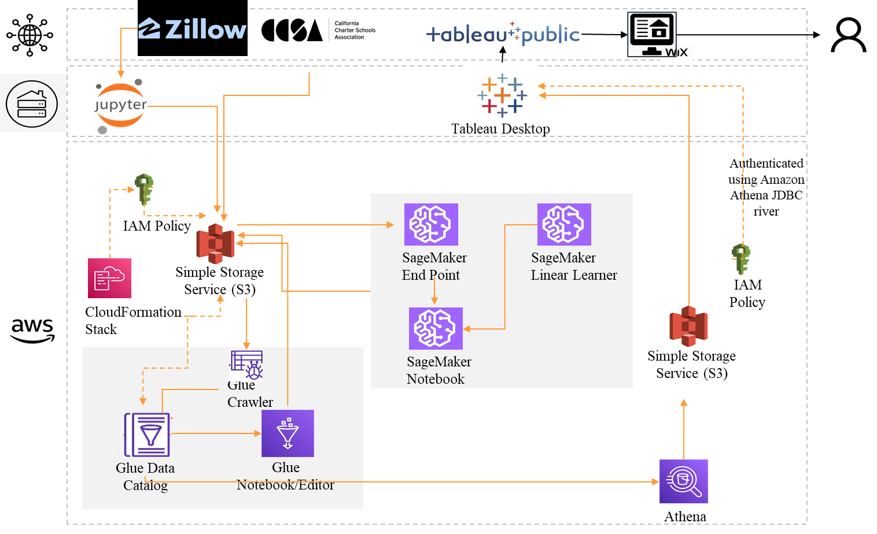

Project Methodology:

1. Business Understanding
   * Problem statement: Build a housing application (with predicted house price)
   * Process Flow definition
   * Domain concepts
2. Data Understanding
   * Univariate distribution (Including target distribution) - Histogram
   * Bivariate with target - Scatter plots
3. Data Preparation
   * ETL
     + Na removal
     + Duplicate removal
     + Unwanted data filtering (NC state removal)
     + Lot area value field creation
     + Merge school data with housing data
   * Preprocessing for modeling
     + Scaling
4. Modeling
   * Regression
   * Features
     + Location related factors - state, city, population
     + Housing attributes - beds, bath, additional attributes, home type, lot area
     + External factors - school rank, # enrollment
5. Evaluation
   * Metrics:
     + Mean absolute error
     + Mean squared error
     + RMSE
     + Median absolute error
     + Explained variance score
     + R2 score
6. Deployment
   * Hosted a Tableau dashboard to Wix site
   * Hosted Web link: [Here](https://sreedivyacheerla.wixsite.com/california-housing-m)